How to deploy the application from gitlab to elastic beanstalk

1.gitlab we have the option direct cicd

Take the normal aws ec2 instance (in this I am using ubuntu)

Install the gitlab Runner

Register the gitlab runner

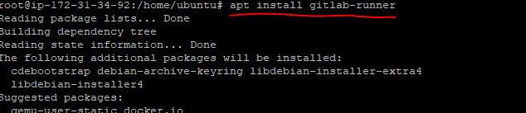

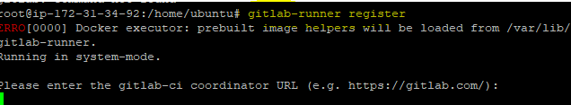

Please enter the gitlab-ci coordinator URL (e.g. <https://gitlab.com/>)

Means go to your git lab account

Go to your repository 🡪left side down (setting)-🡪cicd -🡪Runners

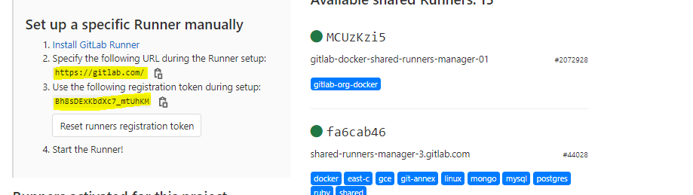

Use above url and and token id for gitlab register

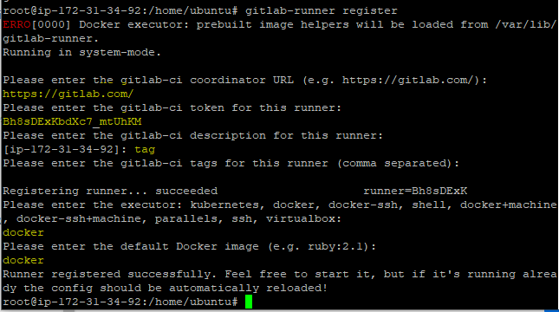

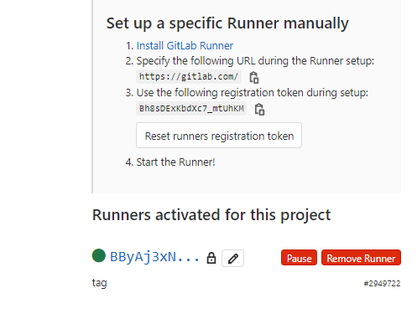

AWS EB

Got to your Aws account create one elastic beanstalk environment

Please note the environment name and app name

This environment name and app name add the your gitlab Variables

Go to your repository 🡪left side down (setting)-🡪cicd 🡪varibles

Acess key id

Secrte acess key

Elastic beanstack env

Elastic bean stack app name

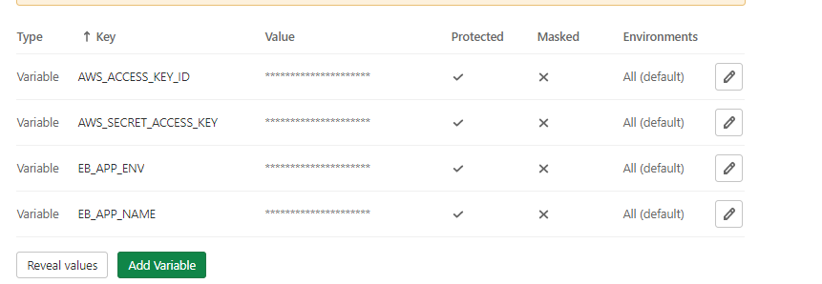

Go to your repository

Pate the .gitlab-ci.yml bellow code

deploy_name:

image: python:latest

stage: deploy

environment: production

script:

- echo "Starting deploy"

- mkdir ~/.aws

- touch ~/.aws/credentials

- echo -e "[albert]\naws_access_key_id=$AWS_ACCESS_KEY_ID\naws_secret_access_key=$AWS_SECRET_ACCESS_KEY" > ~/.aws/credentials

- cat ~/.aws/credentials

- pip --version

- pip install awsebcli

- eb --version

- eb init --region us-east-1 --platform Node.js node

- eb use Node-env

- eb deploy

Automatically deploy your code from gitlab to elastic beanstalk

Note :this cicd is only for deploying the application elastic beanstalk